Sort a given set of N integer elements using Heap Sort technique and compute its time taken.
Bottom up approach and top down approach to be implemented.

#include <stdio.h>
#include <stdlib.h>
#include <time.h>

void heapify_topdown(int arr[], int n, int i) {
int largest = i;
int l = 2*i + 1;
int r = 2*i + 2;

if (l < n && arr[l] > arr[largest]) largest = l;
if (r < n && arr[r] > arr[largest]) largest = r;

if (largest != i) {
int temp = arr[i];
arr[i] = arr[largest];
arr[largest] = temp;
heapify_topdown(arr, n, largest);
}
}
void heapify_bottomup(int arr[], int n, int i) {
while (1) {
int largest = i;
int l = 2*i + 1;
int r = 2*i + 2;

if (l < n && arr[l] > arr[largest]) largest = l;
if (r < n && arr[r] > arr[largest]) largest = r;

if (largest == i) break;

int temp = arr[i];
arr[i] = arr[largest];
arr[largest] = temp;
i = largest;
}
}

void heapSort_topdown(int arr[], int n) {
for (int i = n/2 - 1; i >= 0; i--)
heapify_topdown(arr, n, i);

for (int i = n-1; i > 0; i--) {
int temp = arr[0];
arr[0] = arr[i];
arr[i] = temp;
heapify_topdown(arr, i, 0);
}
}

void heapSort_bottomup(int arr[], int n) {
for (int i = n/2 - 1; i >= 0; i--)
heapify_bottomup(arr, n, i);

for (int i = n-1; i > 0; i--) {
int temp = arr[0];
arr[0] = arr[i];
arr[i] = temp;
heapify_bottomup(arr, i, 0);
}
}

int main() {
int n;
printf("Enter number of elements: ");
scanf("%d", &n);

int *arr1 = malloc(n * sizeof(int));
int *arr2 = malloc(n * sizeof(int));

srand(time(NULL));
for (int i = 0; i < n; i++) {
int val = rand() % 100000;
arr1[i] = val;
arr2[i] = val;
}

clock_t start, end;

start = clock();
heapSort_topdown(arr1, n);
end = clock();
double td_time = ((double)(end - start)) / CLOCKS_PER_SEC;
printf("Top-Down Heap Sort took %f seconds\n", td_time);

start = clock();
heapSort_bottomup(arr2, n);
end = clock();
double bu_time = ((double)(end - start)) / CLOCKS_PER_SEC;
printf("Bottom-Up Heap Sort took %f seconds\n", bu_time);

free(arr1);
free(arr2);
return 0;
}

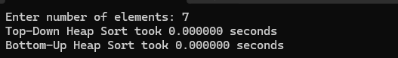

contruct min heap and sort the numbers in descending order.

#include <stdio.h>
#include <stdlib.h>
#include <time.h>

void swap(int *a, int *b) {
int t = *a; *a = *b; *b = t;
}

// ---------- MIN HEAPIFY ----------
void heapify_min(int arr[], int n, int i) {
int smallest = i;
int l = 2*i + 1;
int r = 2*i + 2;

if (l < n && arr[l] < arr[smallest]) smallest = l;
if (r < n && arr[r] < arr[smallest]) smallest = r;

if (smallest != i) {
swap(&arr[i], &arr[smallest]);
heapify_min(arr, n, smallest);
}
}

void buildMinHeap(int arr[], int n) {
for (int i = n/2 - 1; i >= 0; i--)
heapify_min(arr, n, i);
}

void heapSort_min(int arr[], int n) {
buildMinHeap(arr, n);
for (int i = n-1; i > 0; i--) {
swap(&arr[0], &arr[i]);
heapify_min(arr, i, 0);
}
for (int i = 0; i < n/2; i++)
swap(&arr[i], &arr[n-1-i]);
}

int main() {
int n;
printf("Enter number of elements: ");
scanf("%d", &n);

int *arr = malloc(n * sizeof(int));
printf("Enter %d elements:\n", n);
for (int i = 0; i < n; i++) scanf("%d", &arr[i]);

printf("Original array:\n");
for (int i = 0; i < n; i++) printf("%d ", arr[i]);
printf("\n");

clock_t start = clock();
heapSort_min(arr, n);
clock_t end = clock();

printf("Sorted array (Descending using Min Heap):\n");
for (int i = 0; i < n; i++) printf("%d ", arr[i]);
printf("\n");

double time_taken = (double)(end - start) / CLOCKS_PER_SEC;
printf("Time taken: %f seconds\n", time_taken);

free(arr);
return 0;
}

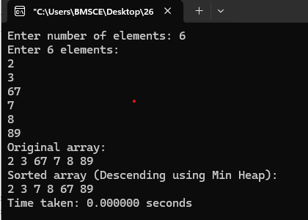

1. Implement Horner's rule for polynomial evaluation.

#include <stdio.h>
#include <stdlib.h>

// Horner's Rule function
double horner(double coeff[], int n, double x) {
double result = coeff[0];
for (int i = 1; i < n; i++) {
result = result * x + coeff[i];
}
return result;
}

int main() {
int n;
double x;

printf("Enter degree of polynomial: ");
scanf("%d", &n);

double *coeff = (double *)malloc((n+1) * sizeof(double));

printf("Enter %d coefficients (from highest degree to constant term):\n", n+1);
for (int i = 0; i <= n; i++) {
scanf("%lf", &coeff[i]);
}

printf("Enter value of x: ");
scanf("%lf", &x);

double result = horner(coeff, n+1, x);

printf("Polynomial evaluated at x = %.2f is: %.2f\n", x, result);

free(coeff);
return 0;
}

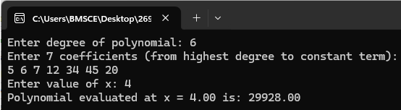

2. Write a program to compute the mode value (apply presorting)

#include <stdio.h>
#include <stdlib.h>

int cmpfunc(const void *a, const void *b) {
return (*(int*)a - *(int*)b);
}

void computeMode(int arr[], int n, int *mode, int *freq) {
qsort(arr, n, sizeof(int), cmpfunc);

int maxCount = 1, currCount = 1;
*mode = arr[0];
*freq = 1;

for (int i = 1; i < n; i++) {
if (arr[i] == arr[i-1]) {
currCount++;
} else {
currCount = 1;
}

if (currCount > maxCount) {
maxCount = currCount;
*mode = arr[i];
*freq = currCount;
}
}
}

int main() {
int n;
printf("Enter number of elements: ");
scanf("%d", &n);

int *arr = malloc(n * sizeof(int));
printf("Enter %d elements:\n", n);
for (int i = 0; i < n; i++) scanf("%d", &arr[i]);

int mode, freq;
computeMode(arr, n, &mode, &freq);

printf("Mode value = %d, Frequency = %d\n", mode, freq);

free(arr);
return 0;
}
